Junior League’s “Kids in the Kitchen” Program
by Robin Shih
April 25, 2011
(Thank you to Robin Shih for providing this Program Summary. In addition to being a fellow Rotarian, Robin is a member of the Junior League of Eau Claire and instrumental in the annual Kids in the Kitchen initiative. )

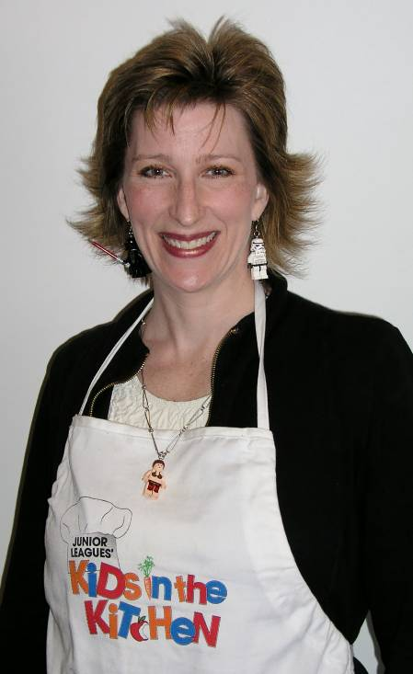
Obesity is now the largest preventable disease threat to our national health. Junior League’s Kids in the Kitchen aims to educate the children, parents, and volunteers about ways to be active and how to enjoy a healthy diet made from wholesome nourishing ingredients. Our fourth annual cooking and nutrition education programs at the Boys & Girls Club, held on Fridays this past March, received rave reviews.
Robin Shih updated our Club on the Junior League’s Kids in the Kitchen program. Robin is a fellow Rotarian and a member of the Junior League of Eau Claire.
Here’s a recap of the fun-action-and-education packed Kids in the Kitchen schedule:
- Friday, March 4 – Laurel Robertson of Dinners On facilitated preparation of turkey chili and oven-baked sweet potato fries and presented on super foods and spices. (www.dinners-on.com)
- Friday, March 11 – Laura Sommer of Just Local Food facilitated preparation of healthy tacos and presented on safe knife skills. (www.justlocalfood.com)
- Friday, March 18 – Trish Cummins and Dr. John Plewa facilitated preparation of grilled chicken with healthy dipping sauces. Kim Ayres of Mission Accomplished presented an interactive program focused on super brain food. (www.kimayres.com)
- Friday, March 25 – Kristina Beuning of Sunbow Farm facilitated preparation of homemade granola. (www.sunbowfarm.com)
We did a raffle drawing each week for Kids in the Kitchen cookbooks in which we have a recipe included. That’s right, I submitted the red pepper hummus recipe to the publisher and it’s now in the book! Books are $21.95 and are available from Robin Shih.
Each day ended by celebrating with a banana and strawberry ‘ice cream’ party. The ‘ice cream’ is actually made by pressing frozen bananas and frozen strawberries into a Champion juicer. HEALTHY AND DELICIOUS! The kids helped work the juicer and are expecting to serve this delicious treat more and more often at the Club. The juicer was made possible in part by a generous donation last year from our Rotary Club. Thank you so much for your support, Rotary!
We welcome your questions, comments and ideas! Our goal is to provide ongoing Kids in the Kitchen programming at the Boys & Girls Club beyond Nutrition Awareness Month, so everyone interested is invited to share your thoughts and suggestions on how best to maintain a consistent educational presence to better serve the children. Let us know what you think! Please contact Robin Shih at rshih@csstars.com. To learn more, please visit the website http://kidsinthekitchen.ajli.org/ which provides materials to support the Kids in the Kitchen initiative including recipes and tips on nutrition. The website features a variety of regularly updated resources to help teach children healthy eating habits and a virtual recipe collection from celebrity chefs, local restaurateurs, celebrity moms, and nutrition experts.

